DATA SHARING & PROTECTION
As per the continuation of previous post (snowflake_28),
Let’s create a data share via UI
First keep your locator ready in your reader/consumer account as shown
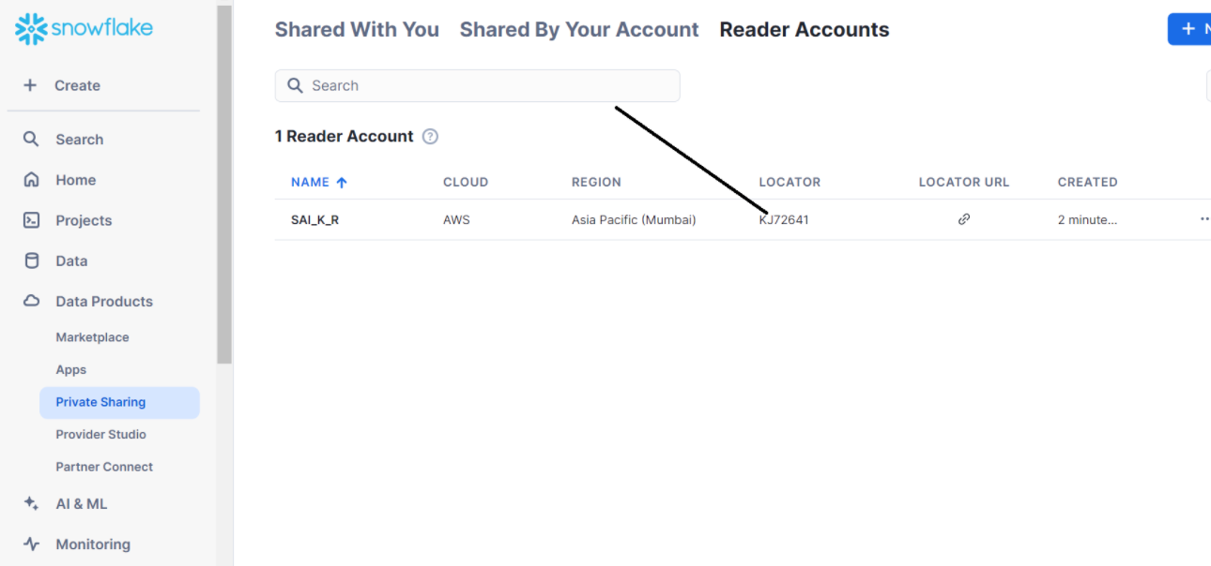
Go to your main account and click on create direct share
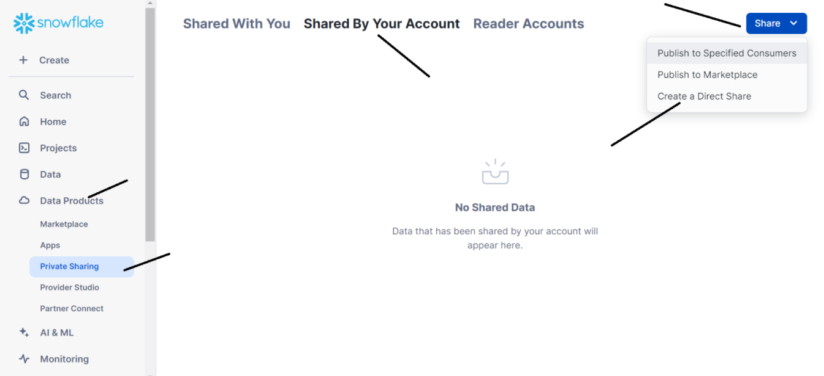
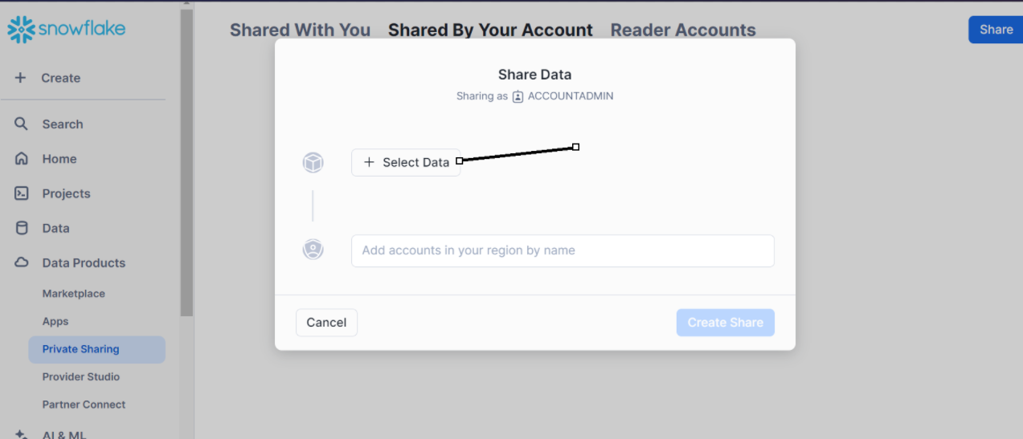
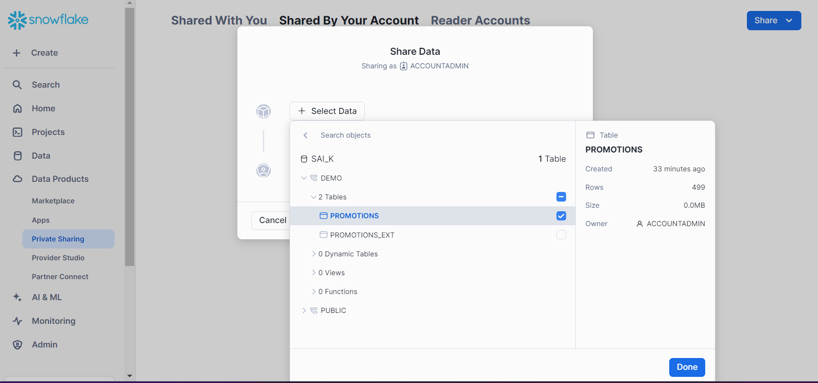
Click on done
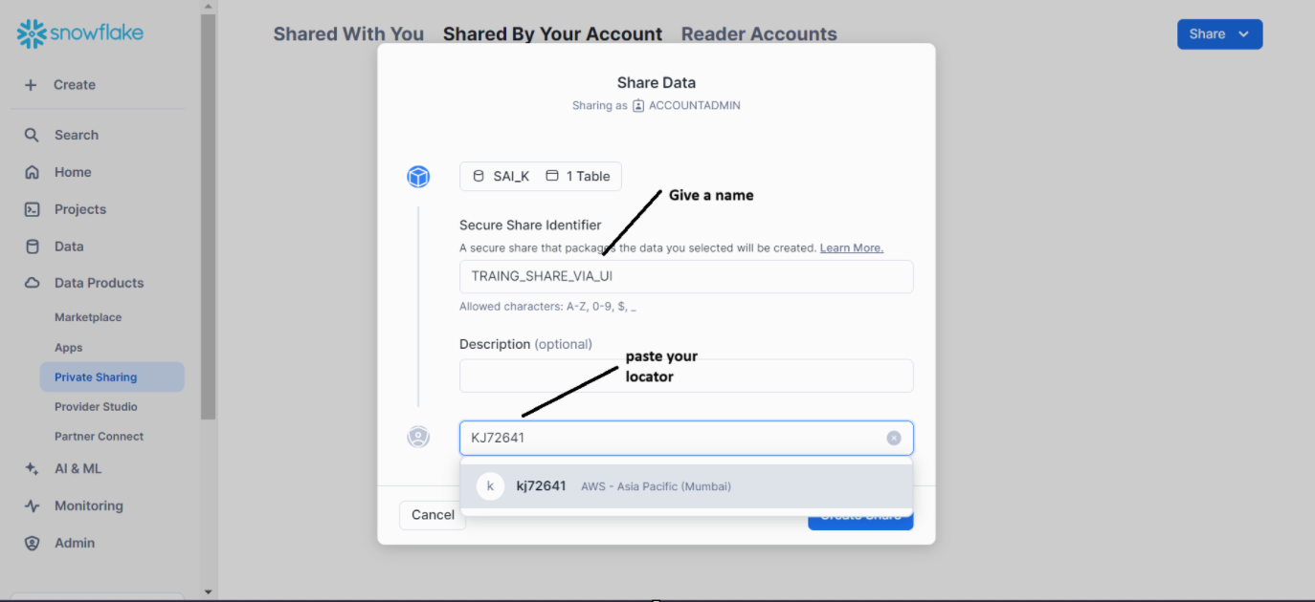
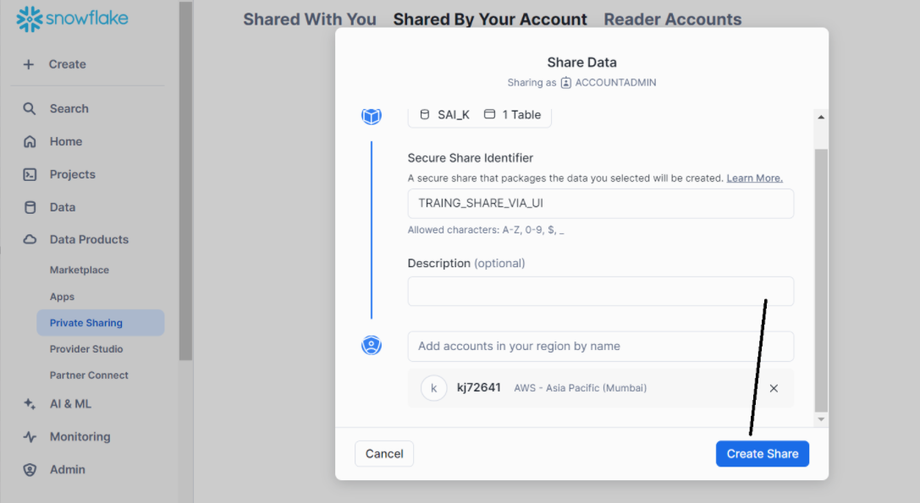
Now, let’s go to your consumer/reader account
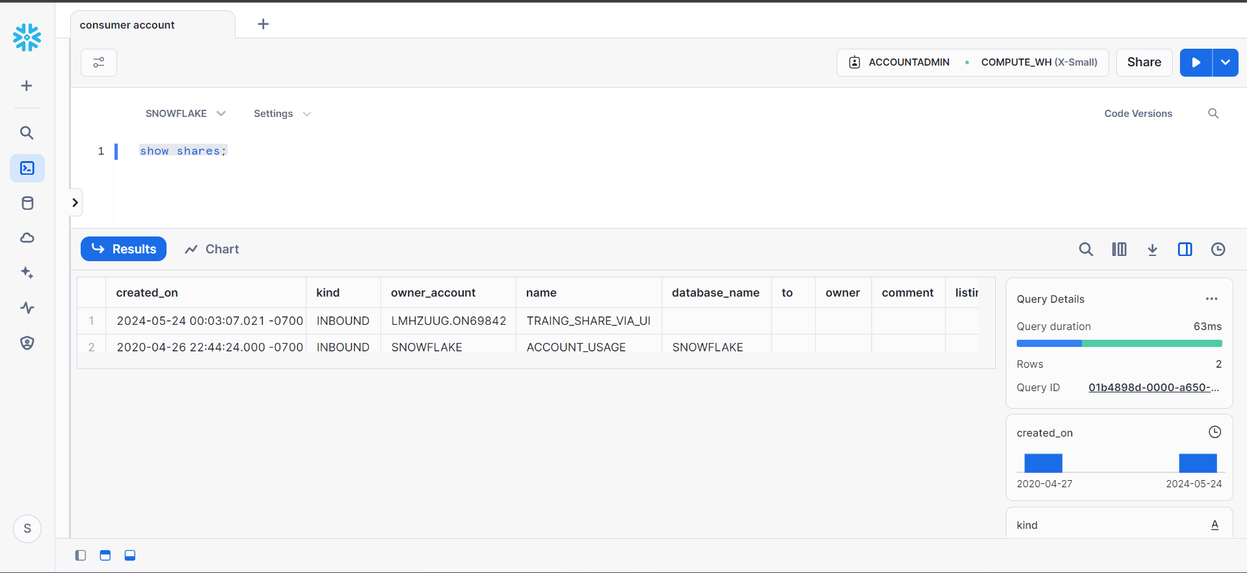

Create a database using owner_account (as per previous post)
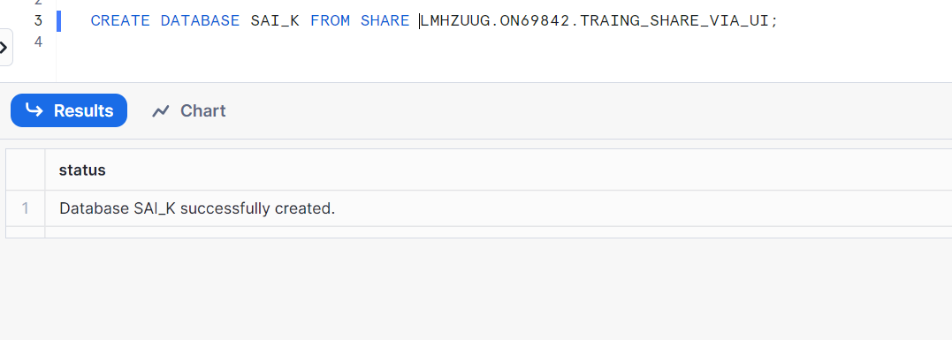
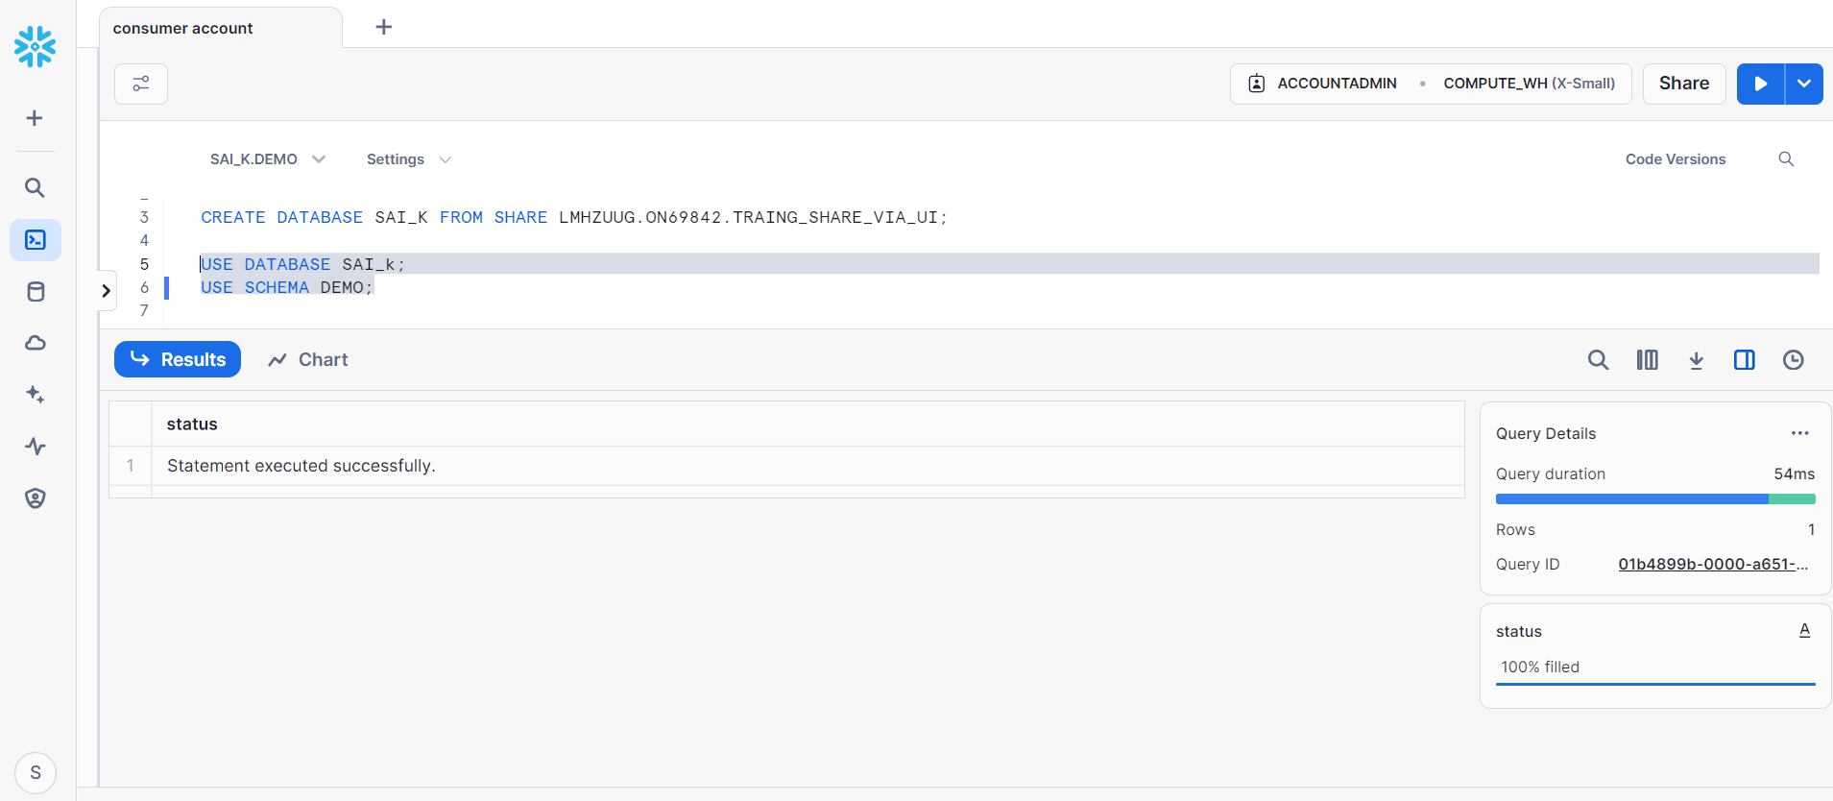
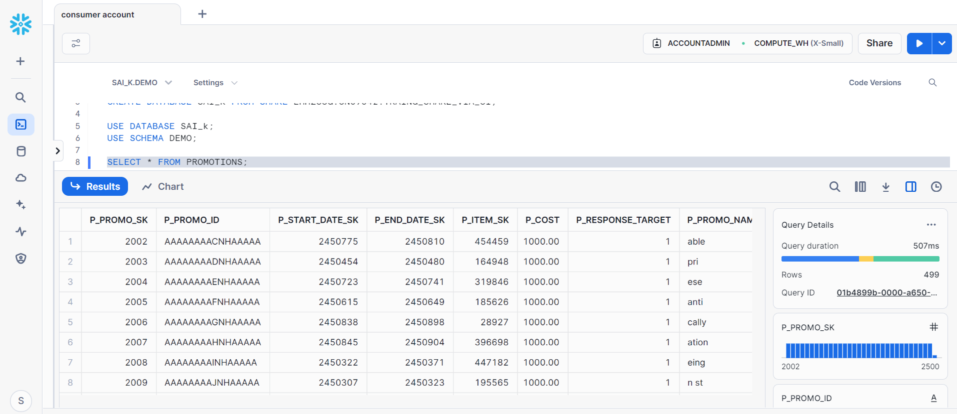
Therefore, we got the data in our consumer account
Note: please follow the previous post carefully with respect to sql commands

Imported privileges:
Let’s do some hands on to understand imported privileges
Go to provider/main account
Create a table
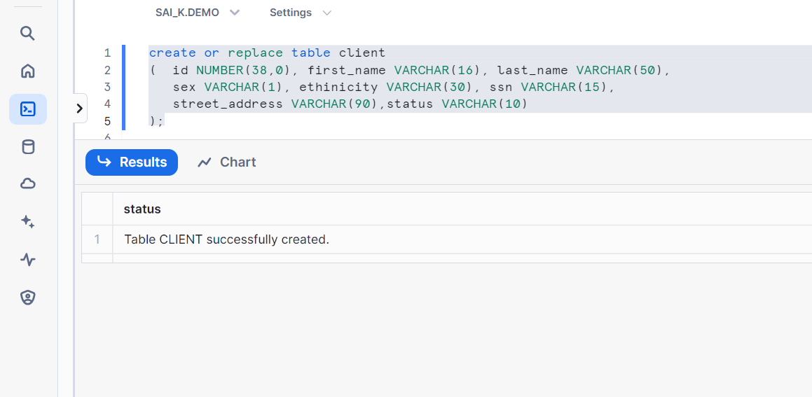
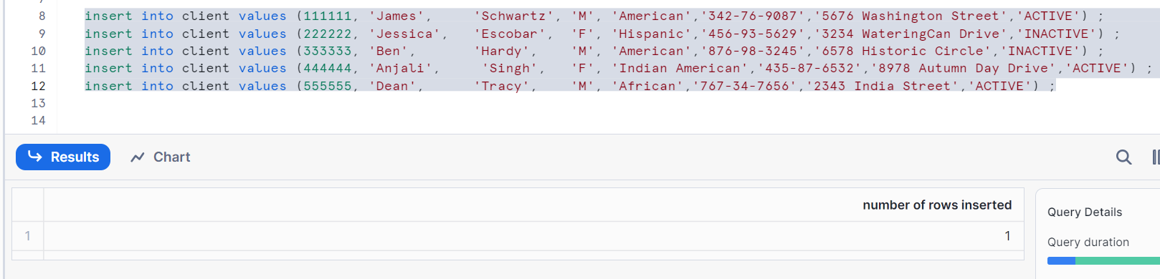
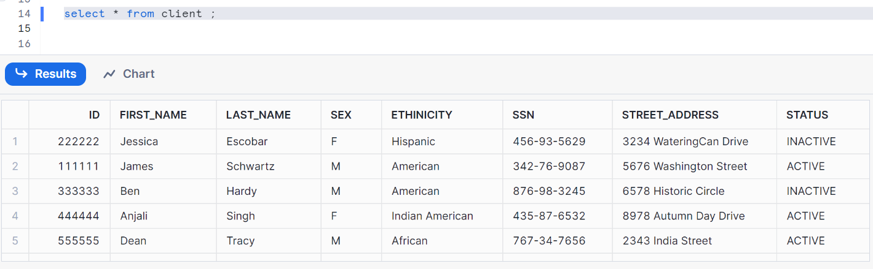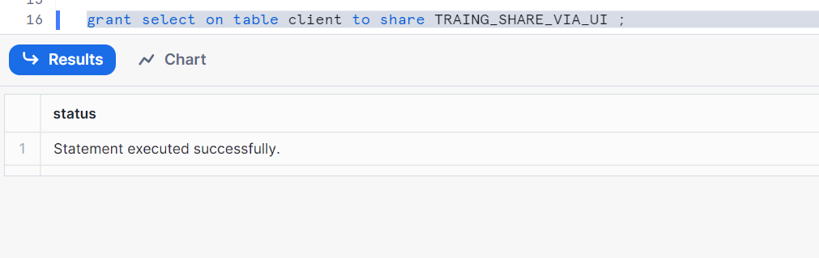
Now let’s go to reader account and check
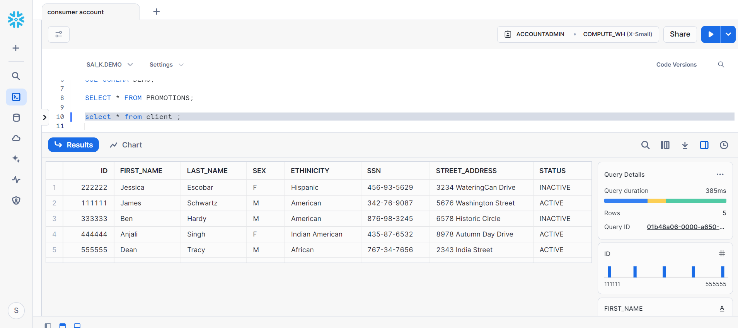

Now if we want to give access to other roles from reader account of this same table, follow below
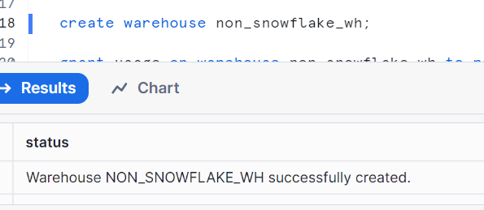
Use this warehouse and create roles
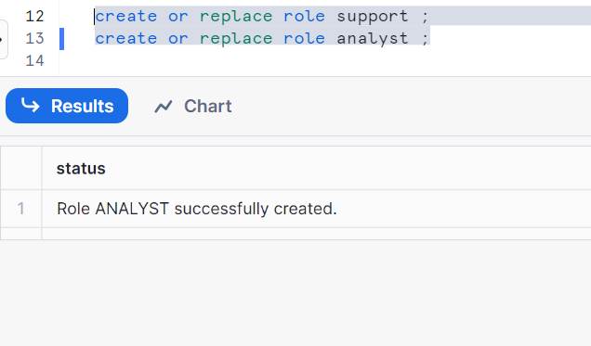
Create a user here in your reader account
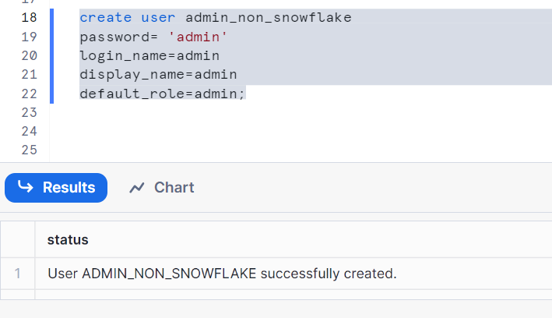
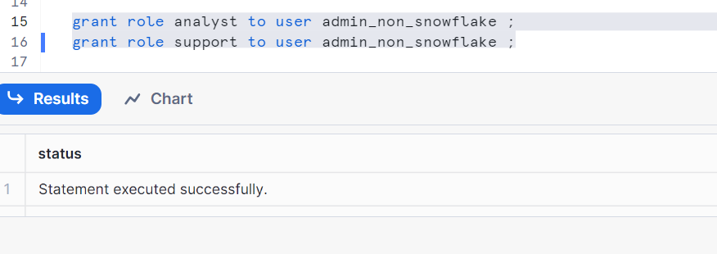
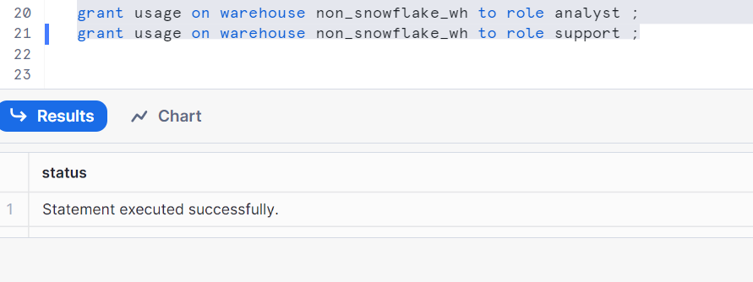
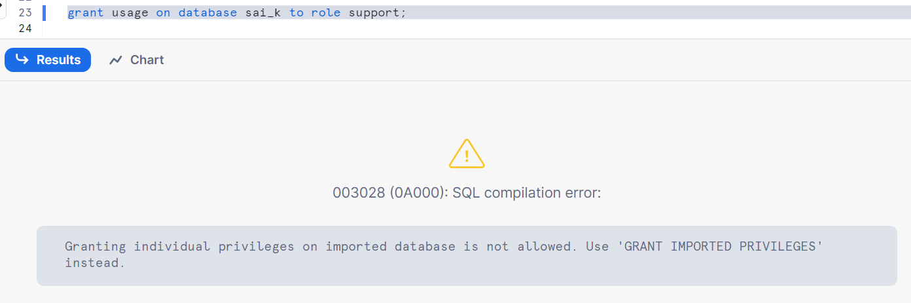
We can’t give grant on database sai_k as this is from our provider account

Hence imported privileges will help us to give access from our reader account as per below
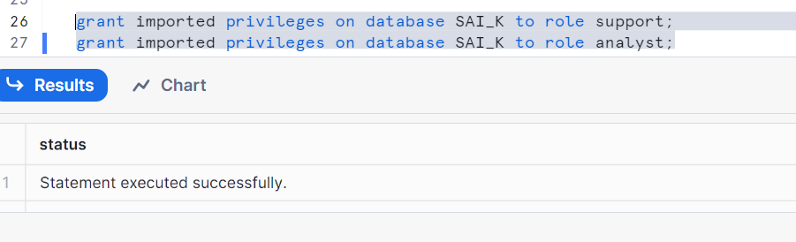
Now, go to your user ‘non_snowflake_wh’ by logging in
Now check the table
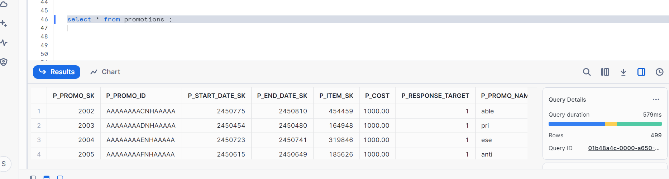
Hence, we first gave access from provider account to reader account, from reader account we had used imported privileges to give access to users

Now, go to reader account and use role account admin
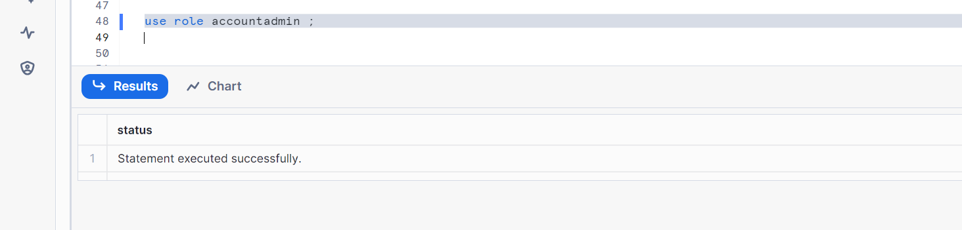

To remove privilege
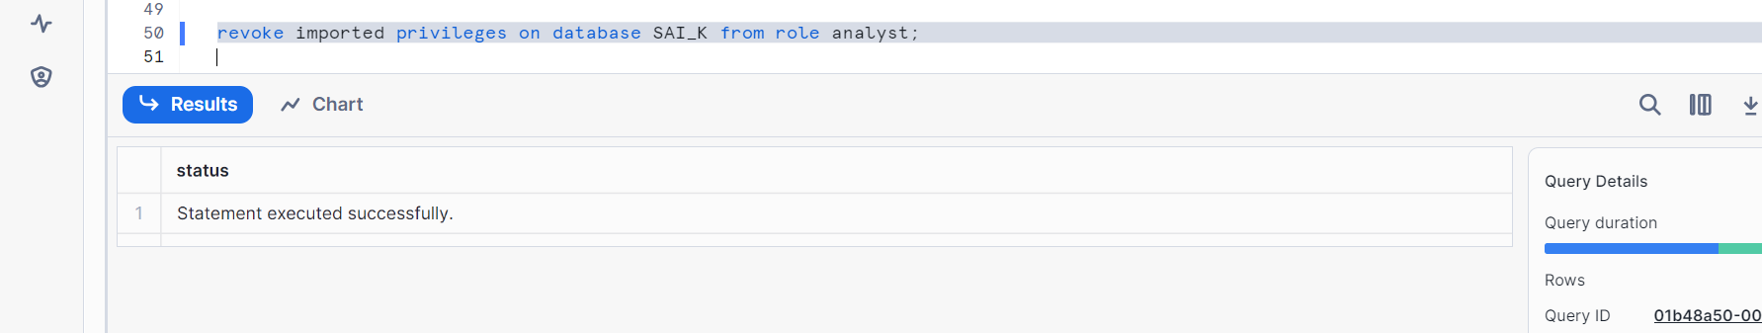
Go to your user ‘non_snowflake_wh’ and check data, the data shouldn’t be present

